SIMATS ENGINEERING
ASSESSMENT TOOL 1

COURSE NAME: Ethical Hacking COURSE CODE: ITA14

COURSE OUTCOME COVERED

CO2: Foot printing Tools: Conducting Competitive Intelligence, DNS Zone Transfers, Introduction to Social Engineering: Social Engineering Attacks and Countermeasures. (BT3)

Assessment Tool Weightage: 30%

Duration: 90 min Total Marks: 50

Report Analysis
Questions

- A security analyst performed a network scan on the target 192.168.1.10 using the Nmap tool. The report identified several open ports, including HTTP (80), SSH (22), and MySQL (3306), along with the operating system and service versions. Analyze the report and explain the security risks associated with the identified services. Discuss how an attacker could exploit these services and recommend suitable security measures to protect the target system. (20 Marks)

- A phishing awareness campaign was conducted for employees of ABC Technologies Pvt. Ltd. using the GoPhish tool. The report indicates that 40% of employees clicked the phishing link, 20% entered their login credentials, and several users downloaded a malicious attachment. Analyze the report and identify the security weaknesses demonstrated by the employees. Recommend suitable user awareness programs, email security controls, and organizational policies to reduce the risk of successful social engineering attacks.(20 Mark).

- A DNS assessment report generated using the Dig tool shows that the organization's DNS server permits a successful DNS Zone Transfer (AXFR), exposing internal hostnames, mail servers, and DNS records. Analyze the report and explain the security implications of the exposed information. Discuss how attackers could exploit these findings and recommend best practices to secure the DNS infrastructure..(10 Marks)

Code of Conduct:

I Ayyan Abhisheshan (192411102) certify that this submission is my original work and that I have adhered to the guidelines specified for this assessment.
I understand that any violation of academic integrity rules will result in disciplinary action.

Signature of the student: Ayyan Abhisheshan

RUBRICS FOR CALCULATION

Report Analysis
Criteria | Weightage (%) | Level 4 (Exemplary) | Level 3 (Proficient) | Level 2 (Developing) | Level 1 (Beginning)
Report Analysis and Interpretation | 25% | Accurately interprets the security report, identifies all key findings, and explains their significance with excellent technical understanding. | Correctly interprets most findings with minor omissions or inaccuracies. | Identifies only some findings and provides limited interpretation. | Unable to interpret the report or identify key findings.
Identification of Security Risks and Vulnerabilities | 25% | Correctly identifies all security risks, vulnerabilities, and possible attack vectors with clear technical justification. | Identifies most risks and vulnerabilities with minor errors. | Identifies only a few risks with limited technical explanation. | Fails to identify major risks or vulnerabilities.
Application of Cybersecurity Concepts and Countermeasures | 30% | Applies appropriate ethical hacking concepts and recommends comprehensive, practical, and technically sound countermeasures. | Recommends suitable countermeasures with minor technical gaps. | Provides limited or partially appropriate recommendations. | Recommendations are inappropriate, incomplete, or missing.
Technical Communication and Documentation | 20% | Response is well-organized, technically accurate, clearly presented, and uses appropriate cybersecurity terminology throughout. | Response is organized and understandable with minor documentation or presentation issues. | Response lacks clarity, organization, or contains several technical inaccuracies. | Response is poorly organized, incomplete, and difficult to understand.

Question 1 — Nmap Network Scan Analysis
(20 Marks)
A security analyst scanned the target host 192.168.1.10 using Nmap and identified three open ports — HTTP (80), SSH (22), and MySQL (3306) — along with the operating system and service versions in use.

1.1 Interpretation of the Scan Report
The Nmap output shows that the host is reachable and running an active web service, a remote-administration service, and a database service simultaneously. Reporting the OS and version banners means the scan was run without stealth or version-hiding precautions, which itself gives an attacker valuable footprinting data before any exploitation begins.

1.2 Security Risks by Service
Open Port / Service | Security Risk | How an Attacker Could Exploit It
HTTP – Port 80 | Unencrypted web traffic; possible outdated web server / CMS; misconfiguration, directory listing, default pages. | Sniff credentials & session cookies in transit; run vulnerability scanners (Nikto) to find outdated software; attempt SQLi, XSS, or file-upload exploits on the web app.
SSH – Port 22 | Weak or default credentials, outdated SSH daemon version, permitted password authentication, no rate-limiting. | Brute-force / dictionary attacks (Hydra, Medusa); exploit known CVEs in outdated SSH versions; gain a remote shell and pivot deeper into the network.
MySQL – Port 3306 | Database exposed directly to the network; weak root/user passwords; unpatched MySQL version; no firewall restriction. | Attempt default-credential login; exploit known MySQL vulnerabilities; perform SQL injection through the linked web app to dump or modify sensitive data.

1.3 How These Services Could Be Exploited
- Reconnaissance and banner grabbing: Version numbers revealed by Nmap let an attacker search public CVE databases (e.g., NVD, Exploit-DB) for matching known exploits.
- Credential attacks: SSH and MySQL are both commonly targeted with automated brute-force tools when exposed directly to the internet.
- Web-to-database pivoting: A vulnerability in the web application on port 80 (e.g., SQL injection) can be chained to reach the MySQL service on port 3306, turning one weak point into full database compromise.
- Lateral movement: Once SSH access is obtained, the attacker can use the host as a pivot point to scan and attack other systems on the internal network.

1.4 Recommended Security Measures

Service | Recommended Security Measures
HTTP (80) | Migrate to HTTPS (TLS 1.2/1.3) with a valid certificate; keep the web server and CMS patched; disable directory listing; deploy a Web Application Firewall (WAF); run regular vulnerability scans.
SSH (22) | Disable password authentication and enforce key-based login; change the default port; enable Fail2Ban / rate-limiting; restrict access via firewall or VPN to authorised IPs; keep OpenSSH updated.
MySQL (3306) | Bind MySQL to localhost or an internal network only; block port 3306 at the perimeter firewall; enforce strong, unique credentials; apply the latest patches; enable database activity logging and least-privilege accounts.

1.5 General Hardening Recommendations
- Close or firewall any port that does not need to be internet-facing; expose only what is strictly required.
- Apply the principle of least privilege to all service accounts.
- Patch operating systems and services on a regular, documented cycle.
- Deploy an Intrusion Detection/Prevention System (IDS/IPS) to flag scanning and brute-force behaviour.
- Conduct periodic penetration testing and vulnerability assessments to catch drift from the secure baseline.

Question 2 — Phishing Awareness Campaign (GoPhish)
(20 Marks)
A GoPhish simulation run for employees of ABC Technologies Pvt. Ltd. found that 40% of employees clicked the phishing link, 20% entered their login credentials on the fake page, and several employees downloaded a malicious attachment.
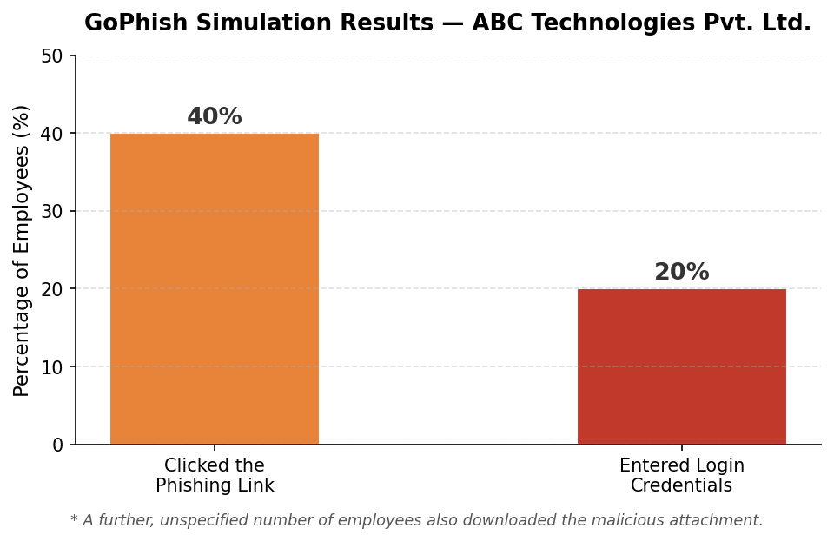
Figure 1: GoPhish simulation results for ABC Technologies Pvt. Ltd.

2.1 Security Weaknesses Demonstrated by Employees
- Low phishing awareness: A 40% click-through rate shows most staff cannot reliably distinguish a malicious email from a legitimate one.
- Poor credential hygiene: 20% of employees entered live credentials into an unverified page, indicating no habit of checking URLs, certificates, or sender authenticity before logging in.
- Unsafe handling of attachments: Downloading and presumably opening an unsolicited attachment suggests a lack of caution around executable content and unfamiliar senders.
- Absence of a reporting culture: The scenario does not mention employees reporting the suspicious email, suggesting there is no established or well-known channel for flagging phishing attempts.

2.2 Recommended User Awareness Programs
- Run mandatory, recurring security-awareness training with real-world phishing examples, not a one-time induction session.
- Conduct periodic simulated phishing campaigns (as done here) with immediate, individualised feedback for anyone who clicks or submits credentials.
- Teach concrete red flags: mismatched sender domains, urgency/fear tactics, unexpected attachments, and suspicious links (via hover-to-preview).
- Gamify awareness with leaderboards or recognition for employees who correctly report simulated phishing attempts.

2.3 Email Security Controls
- Enforce SPF, DKIM, and DMARC to reduce sender-domain spoofing.
- Deploy an email gateway with attachment sandboxing and link-rewriting/click-time scanning.
- Block or quarantine high-risk attachment types (e.g., .exe, .js, macro-enabled Office files) by default.
- Add a prominent "External Sender" banner to emails originating outside the organisation.
- Provide a one-click "Report Phishing" button integrated into the email client.

2.4 Organizational Policies
- Enforce Multi-Factor Authentication (MFA) so leaked credentials alone are not sufficient for account takeover.
- Adopt a least-privilege access model to limit the blast radius of any single compromised account.
- Maintain a documented incident-response plan covering credential resets and endpoint isolation after a suspected compromise.
- Enforce periodic password rotation and prohibit password reuse across systems.
- Measure awareness-program effectiveness over time using click-rate and report-rate trends from repeated simulations.

Question 3 — DNS Zone Transfer (AXFR) Assessment
(10 Marks)
A DNS assessment using the Dig tool found that the organization's DNS server allows a successful zone transfer (AXFR) to an unauthenticated requester, exposing internal hostnames, mail server records, and other DNS entries.
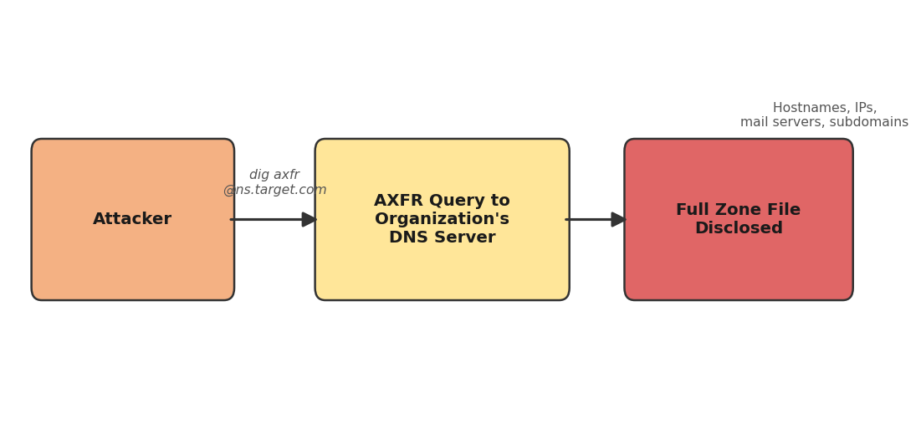
Figure 2: An unrestricted AXFR request discloses the entire DNS zone to any requester.

3.1 Security Implications of the Exposure
- Complete infrastructure mapping: A single AXFR request returns every record in the zone, giving an attacker a ready-made map of servers, subdomains, and services without any further scanning.
- Exposure of internal naming: Hostnames such as internal-vpn, backup-db, or dev-server reveal the existence and role of systems that were never meant to be publicly known.
- Mail server disclosure: MX records identify the mail infrastructure, which can be targeted for phishing spoofing or mail-server-specific exploits.
- Reduced attack effort: Reconnaissance that would normally take extensive brute-force subdomain guessing is reduced to one command.

3.2 How Attackers Could Exploit These Findings
- Use the exposed hostnames as a target list for port scanning and service enumeration.
- Target mail servers directly for spoofing, spam relay abuse, or known mail-software vulnerabilities.
- Identify staging, development, or backup servers that are more likely to be unpatched or weakly secured.
- Combine the zone data with social engineering (e.g., referencing real internal hostnames) to appear more credible to employees.

3.3 Best Practices to Secure DNS Infrastructure
- Restrict zone transfers to explicitly authorised secondary DNS servers only, by IP allow-list (e.g., allow-transfer in BIND).
- Disable AXFR entirely on public-facing authoritative servers where secondary transfers are not required.
- Use TSIG (Transaction Signatures) to cryptographically authenticate any legitimate zone-transfer requests.
- Separate internal and external DNS views (split-horizon DNS) so internal hostnames are never resolvable from the public internet.
- Regularly audit DNS configurations and monitor logs for unexpected AXFR requests.

End of Report Analysis Answers

